*MUHAMMAD USMAN MUHAMMAD YOUSUF

ID: 2012358

SYED ALI SHER

ID: 2012367

HUSSAIN JAFRI

ID: 2012368

**DROPORAMA**

# REASON TO MAKE PROGRAM

We wanted make a difficult application in the simplest way and wanted to do something that we couldn’t find on the internet, to do something unique. Although, had a lot of choices which included a pizza delivery system, banking system and so on but we could find codes like those online. In the end we decided on a transport service system which we got the reference from Uber. Uber is mainly made in python and node.js and has a fantastic GUI.

Unfortunately, as a C beginner we are not able to write a code forming a full GUI in C but a simple user input software is what we are capable of.

Simply said, we decided to make a program that was made in complex languages and took up that challenge to make something unique.

# ABOUT PROJECT

DROPORAMA is a user defined input system which is based on the car service transportation application called Uber. Although Uber was made in Node.js and Python, we wanted to make it in C.

This program takes input from the user about his name, then asks the user about what kind of specific ride class you want to choose. The user gets 5 choices GO, GO+ and of course BUISNESS class. The given car options would be randomly taken by the program’s algorithm depending on the class chosen at the start.

After choosing the user desired class the user will be given an option to choose a driver who will have a fixed rating assigned to his name, it is now where the user will define what kind of driver, he/she wants to choose. The program will then ask the user to confirm the ride.

If chosen to continue the program will ask how much distance in (km) and waiting time in (minutes) have taken during the ride.

There will be a bonus option of the promo codes for the user as well. The final fare will be calculated according to the ride category, distance, time, and the promo code user has inserted. The coupon codes will be “pewdiepie” which will give 2% discount, “HAPPY2021” which will give 5% discount, “HAPPYRIDE” which will give 1% discount.

The final receipt will be shown to the user at the end of the program which will consists of the amount that needs to be paid, the discount from the inserted promo code, the user and captain’s name, car details and the date of the trip.

# Flowchart of the program

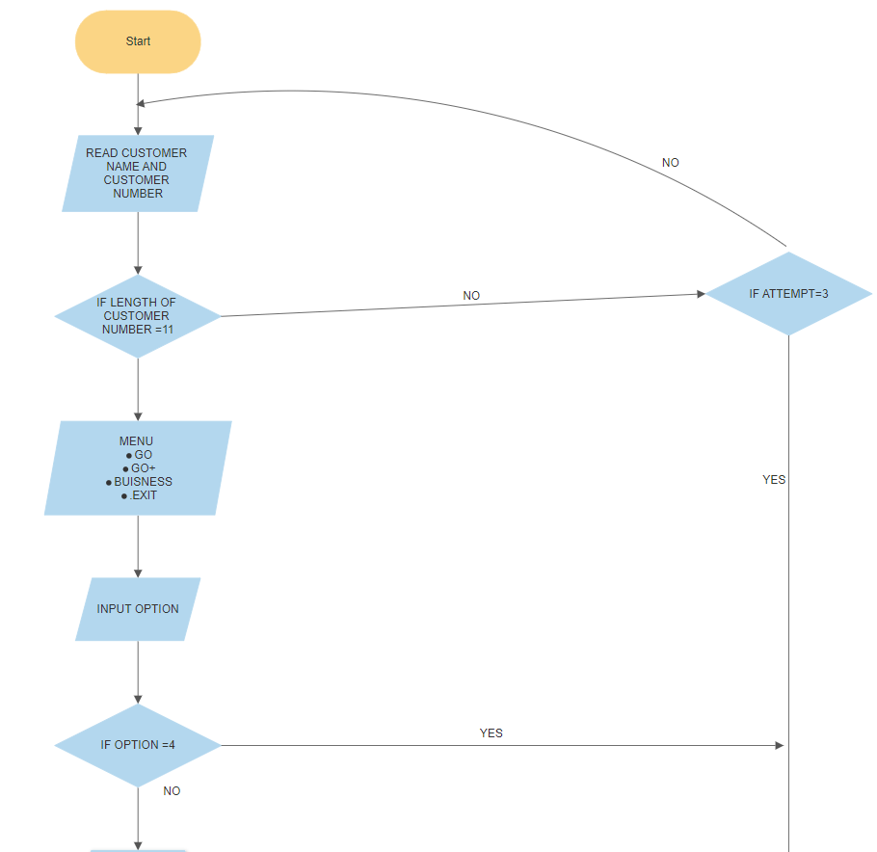

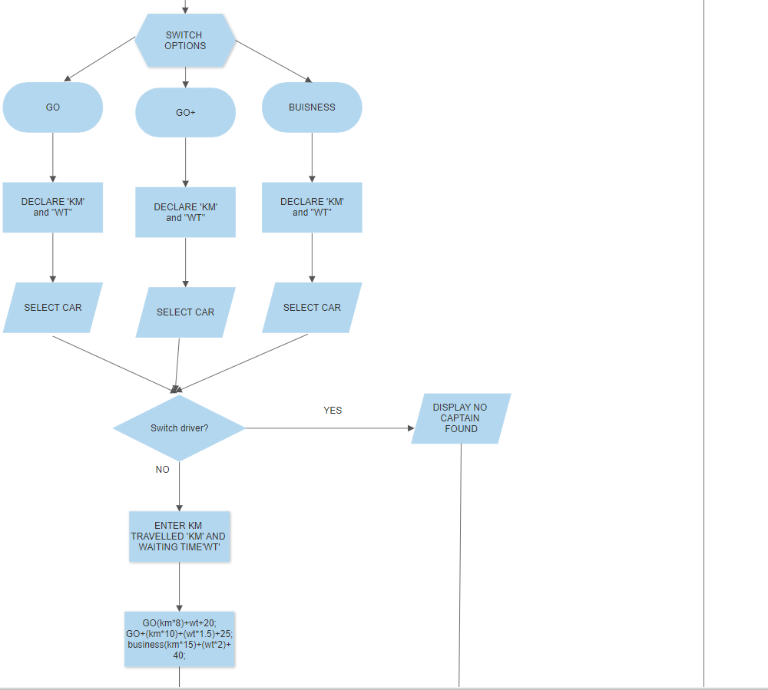

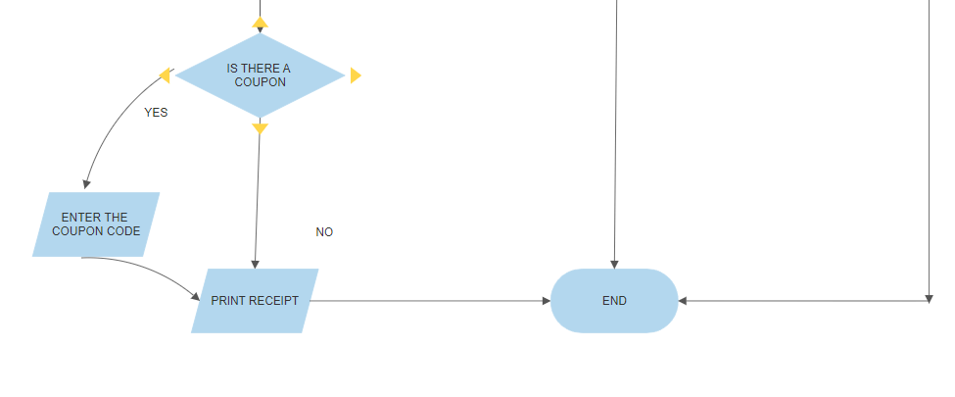

# CHALLENGES:

We faced a quite the bit challenges in which we tried to change our coupon code from percentage to an integer form but for reason the discount output and discounted fare output were coming on the opposite places. In the end we were just forgetting to put a return type. Although we had no idea about the calculation for the fare so we asked around and found a guy who worked as a captain at uber. But with his guidance and experience in the field we devised a suitable solution for the fare value.

Filing was a problem for us with too many projects upon us learning and trying out new things we couldn’t achieve at the time of pressure. It is what we regretted deeply but we are quite proud of what we have accomplished in this project and shows how far we have come.

# Experience:

* We learned well uses of loops
* Structures are great to reduce the need of multiple variables and functions
* We learned how to use 2d arrays
* With string functions, we were able to add many new features in the project.
* We were able to decipher how to code smart.